**2022 SPCP Conference Website**

**Sanitary Measures – COVID 19**

Given the extraordinary context caused by the spread of COVID-19, we are giving you the links to the most up-to-date information about the travel and public health regulations In Canada and Quebec. **The information on these websites prevails at all times:**

* If you travel from outside Canada, find out if you can enter Canada – [Click here](https://travel.gc.ca/travel-covid/travel-restrictions/wizard-start)
* If you want to learn more about COVID-19: Travel, testing, quarantine and borders in Canada – [Click here](https://www.canada.ca/en/public-health/services/diseases/coronavirus-disease-covid-19.html)
* If you want to learn more about the situation in the Québec City area – [Click here](https://www.quebec.ca/en/health/health-issues/a-z/2019-coronavirus/progressive-regional-alert-and-intervention-system/level-1-vigilance-green)
* If you want to learn more about the public health measures put in place by Hôtel Le Concorde Québec – [Click here](https://hotelleconcorde.com/en/pourvotresecurite)

**Québec City is a safe destination where health measures are rigorously applied and we look forward to welcoming you.**

We are looking forward to receiving you in Québec City for 2022 SPCP Conference.

**Vaccination Passport: Since March 14, 2022, the vaccination passport isn’t required anymore in Québec City.

**Travel Authorizations**

# **Need a Visa or eTA?**

Since March 15th, 2016, visa-exempt foreign nationals who fly to or transit through Canada need an Electronic Travel Authorization (eTA). Exceptions include U.S. citizens and foreign nationals with a valid visa.

Canadian citizens, including dual citizens, are not eligible to apply for an eTA and need to travel with a valid Canadian passport.

#### **Find out if you need an Electronic Travel Authorization (eTA) or a visitor visa**

All travelers must present acceptable travel documents and identification must be presented at the border. We strongly suggest that you begin the process as soon as possible to avoid delays.

It is the sole responsibility of the participant to obtain a visa or an eTA. You can request a visa letter during the registration process.

The organizers will not provide financial support.

Please check with the Canadian embassy or consulate for the specific requirements for your country.

**List of Canadian embassies and consulates:**  
<https://travel.gc.ca/assistance/embassies-consulates>.  
  
**Entry requirements by country/territory:**  
[https://www.canada.ca/en/immigration-refugees-citizenship/services/visi…](https://www.canada.ca/en/immigration-refugees-citizenship/services/visit-canada/entry-requirements-country.html)

#### **Letter of invitation for visitor visa**

#### If you need a visitor visa to travel to Canada, we will provide you with a letter of invitation confirming your registration to the conference.

#### An invitation letter for visa application will be sent by email as soon as we receive all the necessary information and the payment of your registration. No invitation letter for visa application will be sent without payment of the registration fees. At the time of registration, you will have the option to request the letter.

#### To fill out the invitation letter appropriately, you will need to provide your passport number arrival/departure dates.

**Eat and Sleep**

**Eat**

1. Québec Regional/Terroir

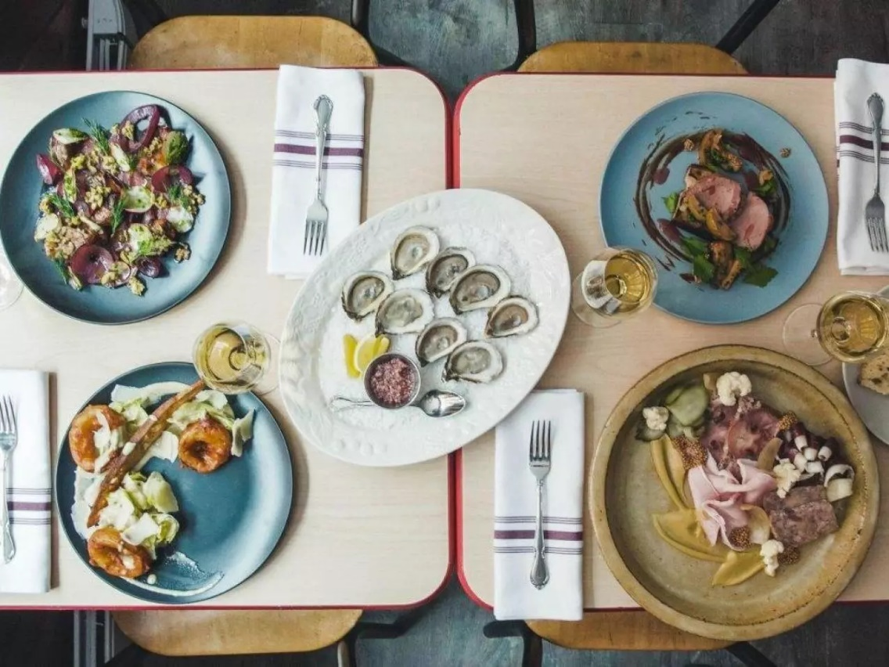

Name: 07_buvette-_390-2018-02-15

* [Alentours](https://www.restaurantalentours.com/) : [Alentours is a sustainable, zero‑waste restaurant that serves exclusively local fare. All its food waste is composted, and all of the ingredients come from within a 150 km radius of the restaurant in Saint‑Sauveur, with the exception of salt and yeast. Chef Moroney, who trained at some of the world’s most celebrated restaurants—including Blue Hill at Stone Barns and Relæ—offers guests a blind tasting menu where everything is made from scratch using ingredients from the restaurant’s 70+ artisanal suppliers. Little wonder it serves some of the best food in Québec City. $$$-$$$$](https://www.quebec-cite.com/en/businesses/restaurant-alentours)
  + [ARVI](https://restaurantarvi.ca/): This little gem in Limoilou is beloved by omnivores and vegetarians alike. Known for sidelining the usual restaurant conventions, it garnered a nod for Best New Restaurant in Canada in 2019 from Air Canada’s EnRoute magazine. Arvi, which means “see you later” in Savoyard, offers an authentic, personal experience. The open‑plan kitchen breaks down barriers, inviting you to admire the work of the staff as they prepare, plate, and serve each dish. The thoughtful presentations and inventive flavour combinations have earned Arvi a well‑deserved reputation as one of the best places to eat in Québec City. Which is why to get a table, you’ll need to book when reservations open for the month and pay in advance. $$$-$$$$
  + [Bistro hortus](https://www.hortus.ca/): The culinary experience at Bistro hortus is one of sustainably sourced ingredients, all traceable from farm to plate. When in season, many even come from the garden and beehives on the roof of the building. Every dish prepared by French chef Stéphane Roth is made using seasonal ingredients prepared on site, almost 90% of which are organic. For fresh local fare, this is one of the best restaurants in Old Québec City. Favorites include the local fish dishes and the veggie‑chip nachos. $$
  + [Buvette Scott](https://www.buvettescott.com/): Buvette Scott has the soul of an eccentric wine bar and a hipster charm that’s never out of place. After just a few minutes tucked into a corner or at the bar, you’ll feel right at home. It’s the perfect backdrop for the cooking of Chef Jean‑Philippe Lessard, which features a few very local, seasonal ingredients and a menu that’s always changing. Add to that the carefully curated wine list with numerous Québec specialties, the impeccable service, and the affordable prices, and you have one of the best local restaurants in Québec City. $$
  + [Brasserie Artisanale La Korrigane](https://www.korrigane.ca/): La Korrigane brews some of the best craft beer in Canada using ingredients from Québec’s boreal forest. Owner Catherine Dionne‑Foster and master brewer Jean‑Sébastien Côté create highly quaffable, unfiltered, unpasteurized beer without any chemicals, preservatives, or artificial flavours. Same goes for the pub‑style menu featuring burgers, fish ’n’ chips, and a delicious poutine with beer gravy. $$
  + [Chez Muffy](https://ulavaldti.sharepoint.com/sites/SPCP-2022-Comit-Activitssocialesettudiantes/Documents%20partages/Comité%20-%20Activités%20sociales%20et%20étudiantes/o%09https:/www.saint-antoine.com/en/chez-muffy): The food at Chez Muffy is steeped in the local terroir and served in a historic location. Attached to Auberge Saint‑Antoine in Québec City’s Old Port, you’ll find the restaurant in a marine warehouse built in 1822. Inside, the colorful furniture and accessories are set off by rustic wood beams, offering a playful contrast that awakens the senses. In the kitchen, the artistry of French chef Arthur Muller plays off the bold flair of chef Alex Bouchard. Together, their cooking expresses Québec’s culinary soul in meals at once comforting and sophisticated, in what is hands‑down one of the best Québec City restaurants in the old city. $$$$
  + [Chez Rioux & Pettigrew](https://www.chezriouxetpettigrew.com/): Rioux & Pettigrew is at one with its surroundings among the antique shops on Rue Saint‑Paul. Located in a former general store of the same name established in 1860, it features beautiful brick walls and creaking old wood floors, along with thoughtful touches like a beautiful old gramophone that make you feel like you’re in another century. Chef Dominique Jacques’s cuisine is everything that’s current and delicious—a must. The restaurant also does a very good brunch, and the house made boudin is legendary. $$$
  + [Clocher Penché](https://www.facebook.com/ClocherPenche/): With a modern interior inspired by the building’s architectural heritage, Clocher Penché is like a fine Parisian brasserie tucked away in Saint‑Roch. Chef Mathieu Brisson serves up fresh market fare in seemingly simple dishes with fabulous depth. These are paired with head sommelier Marc Lamarre’s unique, exciting picks: rare, hard‑to‑come‑by wines that are always at the top of everyone’s list. Be sure to try their housemade faisselle, an unripened cheese that makes a perfect starter or dessert. $$$
  + [Laurie Raphaël](https://laurieraphael.com): The Laurie Raphaël is one of Québec’s true culinary pioneers. Deftly led by the Gagnon-Vézina family, this fine‑dining institution has been one of the top restaurants in Québec City for 30 years. In the kitchen, chef Raphaël Vézina follows in the footsteps of his father, famous chef and author Daniel Vézina, as he brings out the best of the local terroir. The place to go when you’re in the mood for a refined, elegant meal. $$$$
  + [Légende by La Tanière](https://restaurantlegende.com/): Légende is a gastronomic bistro by La Tanière—the restaurant group behind Tanière³ and Orygine—with the intriguing Elliot Beaudoin as its chef. The young kitchen virtuoso lets his love of the unusual lead him to new flavours found only in Québec, including herbs, roots, and leaves hand‑picked in the boreal forest. All the ingredients are locally sourced, for a menu full of culinary adventure. $$$$
  + [L’Orygine](https://lorygine.com/): Talented chef Sabrina Lemay brings all the colours of Québec’s biodiversity to the table, from land and from sea. She cooks with sustainable ingredients sourced largely from small local producers in a style that makes it easy to eat vegetarian, vegan, or gluten‑free and still win on beauty and taste. L’Orygine’s interior is filled with light and doused in shades of turquoise and warm sand. When the weather’s warm, the restaurant is also home to one of the city’s prettiest patios. $$$
  + [MAUDE épicerie/Laboratoire](https://www.chezmaude.com/): This culinary hybrid combines cooking and local ingredients in a venue that’s as natural as chef owner Maude Desroches herself. The small space in Limoilou’s Maizerets neighbourhood carries fresh ingredients from local producers as well as prepared meals, and has a dining area where you can grab a simple, tasty bite for breakfast, lunch, or dinner. Maude’s is a popular brunch spot and also a favourite for drinks after work thanks to the fine selection of Québec beer and private‑import wine. $
  + [Tanière³](https://taniere3.com/): Located in underground vaults that date back to 1686, Tanière3 treats you to an immersive culinary experience orchestrated by the young and highly talented chef François‑Emmanuel Nicol. Truly one of the top restaurants in Québec City, this culinary tour de force of contemporary Québec cuisine features sustainable ingredients and seasonal fare. Want to take your meal to the next level? Have a seat at the bar and order the tasting menu, served and presented by Nicol himself. $$$$
  + [Verre Pickl’](https://www.verrepickl.ca/): Chef Alexandra Romero has turned a hole in the wall into one of the best places to eat in Québec City. Bringing her Mexican heritage to bear on local fare provides a welcome, colourful spin for this popular food movement. Verre Pickl’ is a place for surprising encounters both at and between tables, thanks to the cozy proximity of the guests. The wine menu is regularly updated and features a nice selection of natural wines. Reservations required. $-$$
  + [Café au bonnet d'Âne](http://new.aubonnetdane.com): This friendly café-bistro located in the Faubourg Saint-Jean-Baptiste is a great place to stop. In a period decor and friendly atmosphere, it serves bistro classics, as well as delicious brunches. $$
  + [Restaurant 1640](https://www.bistro1640.com/): From its large terrace, Bistro 1640, located on Saint-Anne Street, overlooks the city and offers a magnificent view of the Château Frontenac. $$
  + [Alphonse](https://alphonse.ca/): Gourmet and refined cuisine articulated around local Quebec products (Pasta, fish, salads, meat, vegetarian and vegan dishes). $$ - $$$
  + [Bistro L'Orygine](https://lorygine.com/): Discover modern and local cuisine where vegetables take pride of place! They offer a creative and varied menu with several meat and fish options from sustainable sources. $$
  + [Ciel! Bistro-bar](https://cielbistrobar.com/): With its 360-degree view of the river, the mountains and all the tourist attractions of Quebec City, this restaurant offers a breathtaking show every day. To savor reinvented local dishes or to enjoy cocktails in the evening. $$$
  + [Louise Taverne & Bar à vin](https://www.louisetbv.ca/): Gourmet tavern and wine bar in the Old Port! Chef Nikolas Couture and his passionate team welcome you in a warm atmosphere and offer a qualitative and tasty cuisine, an attentive and relaxed service as well as a nice selection of privately imported wines, cocktails, spirits and beers. $$
  + [Chez Boulay – Bistro boreal](https://chezboulay.com/):This French‑style bistro is an ode to Québec’s boreal forest, a place where chef Arnaud Marchand and his kitchen brigade turn out voluptuous sauces that seduce and surprise. Star ingredients of Chez Boulay – Bistro boréal include sea lion, beef gravlax, tuna from the Gaspé Peninsula, hazelnuts from Cap‑Tourmente, and cherries from Île d’Orléans. If you’re looking to eat at one of the best restaurants in Old Québec, this is it. $$$-$$$$
  + [Alphonse Cuisine et Cocktails](http://alphonse.ca/): Gourmet and refined cuisine articulated around local Quebec products. Pasta, fish, salads, meat, vegetarian and vegan dishes.

1. Quebec Local

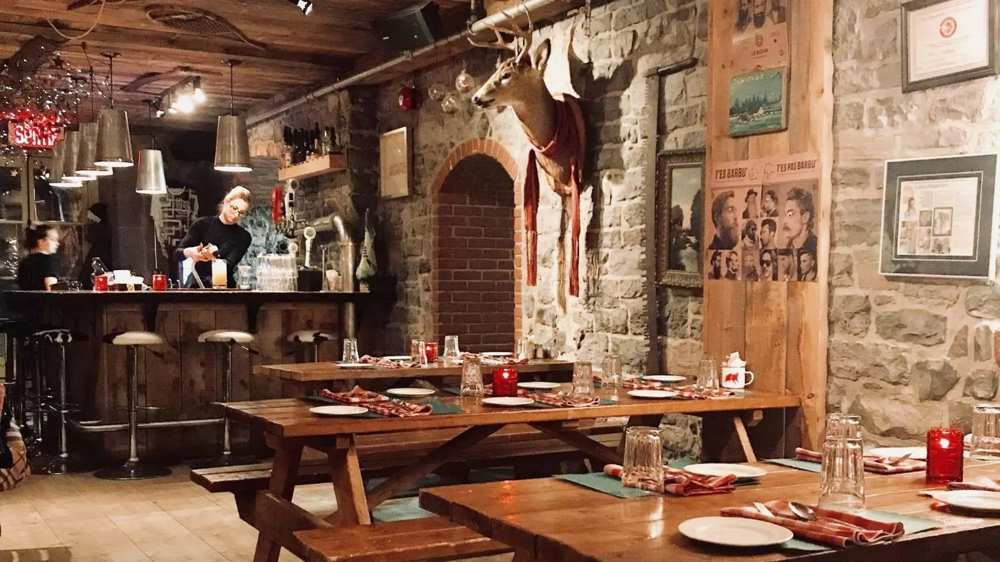

Name: img_6162-002

* [Kebec Club Privé](https://www.kebecclubprive.ca/): Kebec Club Privé is inspired by the underground dining scenes of Chicago and New York. Chef owners Pier‑Olivier Pelletier and Cassandre Osterroth welcome guests to their chic commercial loft in Saint‑Roch, where they cook and serve sophisticated 10‑course meals on one big, long table. The delicious, inventive dishes shine a spotlight on local ingredients and draw their inspiration from Québec’s culinary roots. An innovative experience and some of the best food in Québec City. $$-$$$
* [Le Clan](https://restaurantleclan.com/): Chef Stéphane Modat uses bold methods and a refined sensibility to deliver a culinary coup d’éclat. The acclaimed, award‑winning chef’s new restaurant in Old Québec serves up edible works of art in an eclectic restaurant that soars above the usual fine‑dining conventions. The menu at Le Clan digs deep and travels far to serve you Québec’s tastiest morsels, from bread baked with Côte‑Nord seawater to Stimpson surf clams. A rising star among the best restaurants in Old Québec City. $$$
* [La Buche](https://www.restolabuche.com/): Restaurant offering traditional Quebec cuisine with a modern twist, such as a decomposed shepherd's pie, the famous tourtière du lac, good old-fashioned leg stew, meat pie croquettes and venison tartar. All this in a unique eclectic decor and festive atmosphere! $$
* [District Saint-Joseph:](https://ulavaldti.sharepoint.com/sites/SPCP-2022-Comit-Activitssocialesettudiantes/Documents%20partages/Comité%20-%20Activités%20sociales%20et%20étudiantes/districtstjoseph.ca/District-Saint-Joseph/District-Saint-Joseph) Restaurant - Bar - Showroom. Come and discover Chef Seb Laframboise's highly sought after and comforting cuisine and its smokehouse on site! High-end cocktail bar as well as various concerts in a room with impeccable acoustics. Visit our website to learn more about our upcoming events. $$
* [Le Chic Shack](https://lechicshack.ca/en/?utm_source=quebec-cite.com&utm_medium=affiliate&utm_campaign=OTQ&utm_content=web): Known for its brioche bread burgers, creamy milkshakes and decadent poutines, it’s the homemade sodas and ice cream sandwiches that seal the deal. Don’t be alarmed by the cafeteria feel, but reassured by the first bite that will make it feel so authentic. Even though Le Chic Shack is located in the most tourist-friendly part of town, it is far from being a tourist trap! $$
* [Le Lapin Sauté](https://www.lapinsaute.com/?utm_source=quebec-cite.com&utm_medium=affiliate&utm_campaign=OTQ&utm_content=web#/english): The Lapin Sauté is in Québec's Petit-Champlain district. With its country-in-the-city feel and creative cuisine, it's easy to fall in love with this delightful little neighbourhood restaurant and its delicious grilled meat and gratins at more than affordable prices. On weekends and holidays, patrons come here for the great brunches and to start the day off right, whether by the fire during the winter or on the outdoor terrace during the summer. $$
* [Buffet de l’Antiquaire](https://lebuffetdelantiquaire.com/?utm_source=quebec-cite.com&utm_medium=affiliate&utm_campaign=OTQ&utm_content=web): Tiny neighbourhood restaurant with a friendly family-type atmosphere. Authentic, traditional Québec cuisine found nowhere else. Fresh produce from the market. "Québécois" breakfasts with baked beans and homemade jams are one of our specialties. Served at all hours of the day. Shady terrace to relax as you eat. The Buffet de l'Antiquaire offers fine food at popular prices and is highly recommended. $
* [L’Affaire est Ketchup](https://www.facebook.com/laffaireest.ketchup/): Apartment vibe, chirpy service, energetic wine list and menu presentation where food is prepared on ordinary stoves. That in itself is a sight to see. Seasonal ingredients, saucy dishes and carefully selected alcohol presented in vintage plates and witty decor. It’s also the best sweetbread I have eaten in Canada.
* [Diner Saint-Sauveur](https://www.dinersaintsauveur.ca/?lang=en): A new kid in town with a retro-styled, kitschy eclectic vibe serving a Québécois spin on southern-style soul food. It’s something between a neighbourhood café and a greasy spoon : chicken and waffles, foie gras Sheppard’s pie and lots of funky sides. No reservations and must have desserts.
* [Les Trois Garçons](https://bistro3garcons.com/): The three owners and their team offer you a warm and friendly service while serving you mostly local Quebec products. On any occasion and every day of the week, enjoy the specialties offered on the menu: gourmet burgers, gourmet salads and breakfasts. $$
* [L'Atelier](https://bistrolatelier.com/): Sophisticated gastropub with a light atmosphere offering craft cocktails, tartars and cooked dishes. $$$

1. Italian

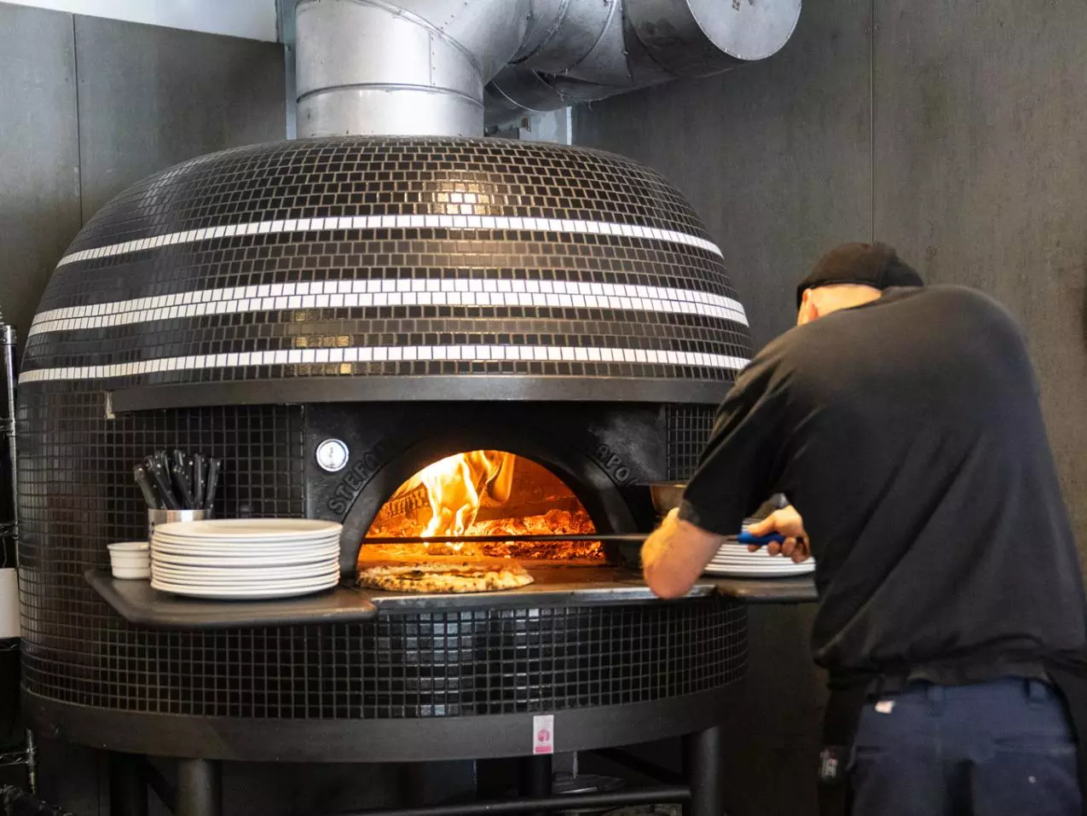

Name: Quebec-Nina-Pizza-credit-Simon-Jodoin-040920-004

* [Battuto](https://battuto.ca/): With its refined and minimalist take on contemporary Italian cuisine, Battuto is something of an anomaly in Québec City’s culinary landscape. The team, made of up chef Guillaume Saint‑Pierre, baker and pastry chef Paul Croteau, and sommelier Pascal Bussière, serves up classic Italian dishes with a new‑bistro twist and a loving dose of French inspiration. And like all good nonnas, the food fairies at Battuto make their own bread, pasta, and sauces daily. That and the attentive, impeccable service explain why Battuto was named Best New Restaurant in Canada in 2018 by Air Canada’s EnRoute Magazine. As one of the top restaurants in Québec City, it rarely has an empty table, so book as far ahead as you can. Reservations are hard to come by, but they’re worth the wait! $$$
* [Nina Pizza Napolitaine](https://ninapizzanapolitaine.ca/): Cooked in a wood‑ or gas‑fired oven, Nina’s pizzas are steeped in a 4,000‑year‑old tradition: the art of the pizzaiolo. These masterful pies are made just as they should be, i.e., baked for 90 seconds and topped with ingredients hand‑picked by chef Véronique Schinck at the Saint‑Jean‑Baptiste location and by chef Alex Gallant at the Saint‑Roch location. For the full experience, get the burrata as an appetizer, order extra pancetta on your pizza, pair it with a glass of natural wine, and toast la bella vita at what is by far one of the best restaurants in Québec City for pizza. $$
* [Sapristi](https://sapristi.ca): Italian foor, pizza & pasta, cocktail bar; $$
* [Bello Ristorante](https://www.belloristorante.com/accueil/): Refined Italian restaurant serving risotto, pasta and homemade pizzas with a terrace offering stunning views. $$$

1. Japanese

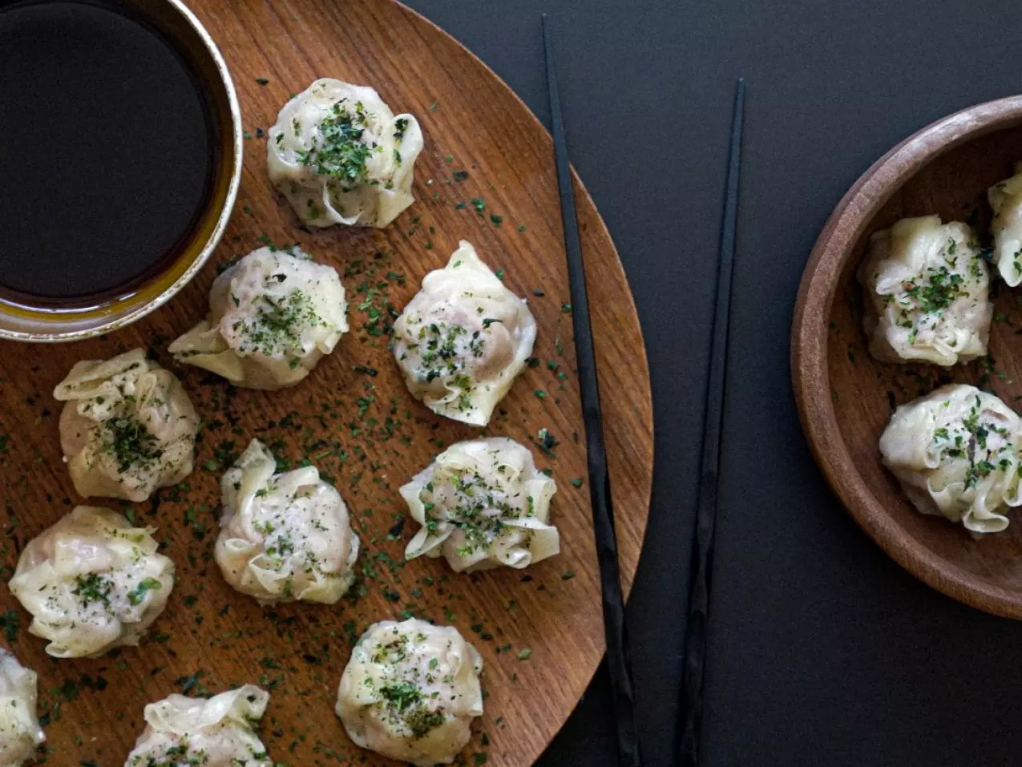

Name: 226149741_2630343083928987_1313528146689249524_n

* [Hono Izakaya](https://honoizakaya.com/): If a Japanese brasserie and a cocktail bar had a lovechild in one of the Lower Town’s hippest hoods, that child would be Hono Izakaya. The restaurant’s light, airy interior makes gorgeous use of unfinished surfaces, wood, metal, and leather, for a new take on a tavern‑style restaurant. The menu pays tribute to the land of the rising sun, with flavours and textures that will whisk you away. Every charcoal‑grilled yakitori is an ode to Japan that simply must be shared among friends. Umami, anyone? $$
* [Tora ya Ramen](https://www.torayaramen.com/): Everyone who walks through the door at Tora ya Ramen is greeted with a loud, happy “irasshaimase” and the scent of delicious broth prepared according to chef owner Miyano Sakai’s family recipes. The ramen here is so divine, people line up around the block for a little Japanese‑style comfort food, even in the coldest months. The drinks menu features imported spirits, beer, umeshu (plum wine), and sake. The restaurant doesn’t accept reservations and the whole menu is available for takeout. $$
* [Bô cuisine d'Asie](https://bocuisinedasie.com/): BŌ Cuisine d'Asie, the steamy experience at Capitole de Québec. Be charmed by our cuisine with bright, straightforward and balanced flavors composed by Chef Vincent Morin. A menu that highlights Quebec's local artisans. $$

1. French

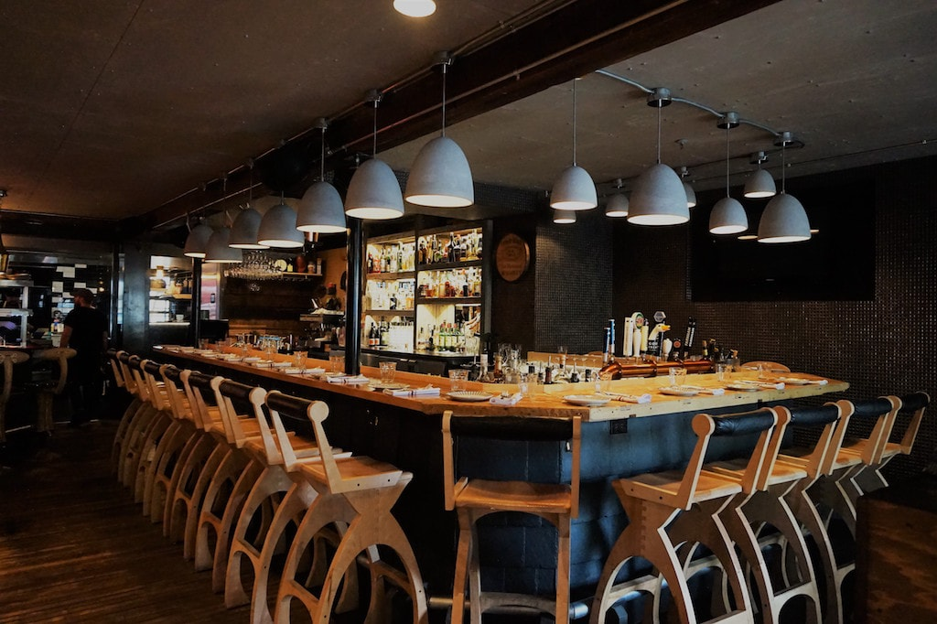

Name: cendrillon-resto-bar-limoilou-quebec-3

* [Pied Bleu](https://piedbleu.com/): This Lyon‑style bouchon with deep local roots should be on everyone’s list of where to eat in Québec City, with meals as copious as they are delicious. Power culinary couple Thanya Goyette and Louis Bouchard-Trudeau take a whole‑hog approach to cooking, turning out fantastic housemade charcuterie, terrines, rillettes, and pâtés, not to mention a boudin that was named one of the best in the world by Normandy’s famous brotherhood of boudin tasters, the Chevaliers du Goûte-Boudin de Mortagne-au-Perche. The prepared meals are also a must, as is the brunch. $$$
* [Le Saint-Amour](https://www.saint-amour.com/): Award-winning restaurant with a romantic ambiance serving French cuisine including tasting menus. $$$$
* [L'Échaudé](https://echaude.com/): Chic and lively bistro offering modern French cuisine and a mostly European wine list. $$$
* [Café du Monde](https://www.lecafedumonde.com/): Located on the banks of the St. Lawrence River in Quebec City, this café seduces with its Parisian touch. On the terrace or in the dining room, the view is breathtaking. They serve great classics of French cuisine revisited. $$$
* [Le Cendrillon](https://lecendrillonrestaurant.com/en/): Our friendly restaurant offers a late dining experience. Just like Cinderella, you have until midnight to enjoy our cuisine and warm atmosphere. You'll love our homemade deli meat, and our selection of Québec cheeses is different varieties of tasty! After a pleasant stroll in the neighbourhood, come enjoy one of our classic cocktails, a glass of one of the many types of beer we have on tap or something from our wine list featuring many Canadian vintages. To top it off, our eclectic décor is absolutely delightful! $$$
* [Brasserie Française Chez Jules](https://chezjules.ca/en): A traditional French brasserie set in a charming contemporary yet history-filled décor. The low ceiling and exposed stonewall improve the setting. Indulge in pan-seared foie gras, frog legs and Burgundy escargots as if you were in Paris. Do leave room for dessert, especially the tarte Tatin topped with a delectable homemade caramel ice cream.

1. Thaï

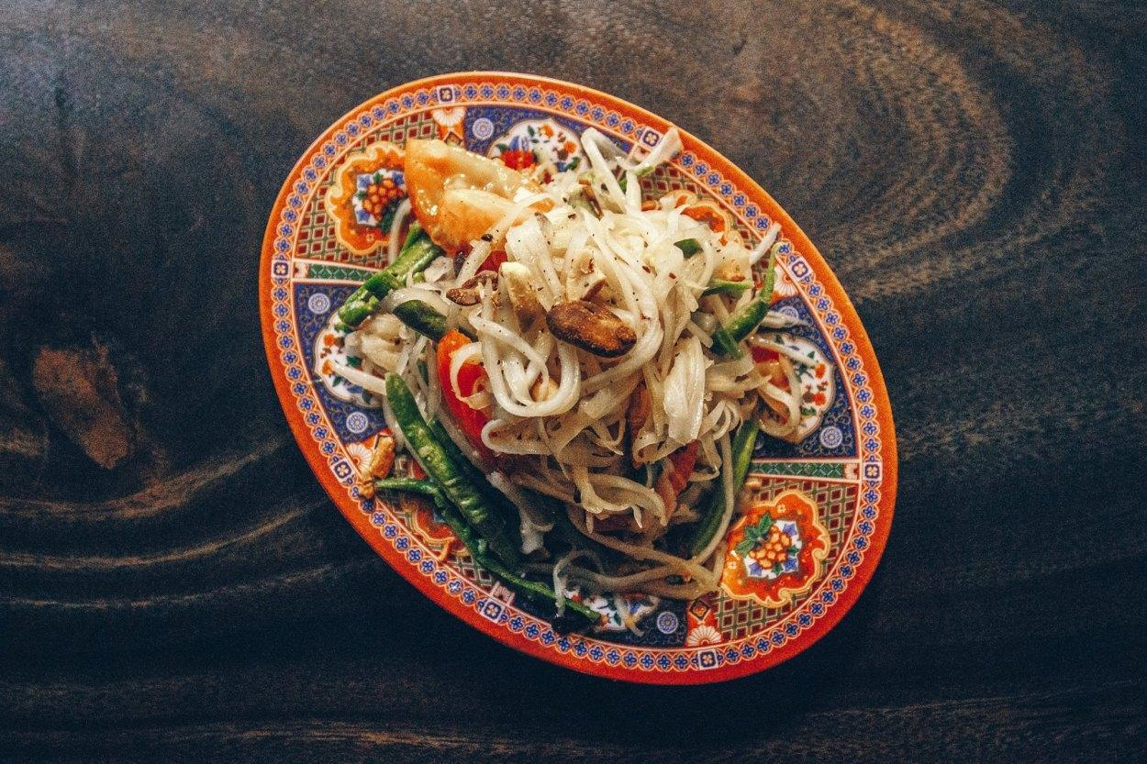

Name: 01_chez-tao_51-2020-06-17

* [Chez TAO!](https://cheztao.ca/): Considered by many to be the nocturnal meeting place for restaurants in Quebec City, the Tao bar vibrates thanks to the inclusive energy of Francis Bernard and Mary Kim Blackburn, who cheerfully mix the creations of owner Vincent Thuaud. The latter stand out for their exoticism, from the choice of ingredients that dare to be spicy and smoky to the distinctive presentation (as with the famous glass-cat). We mop it all up with some Thai-inspired street food! $$

1. Mexican

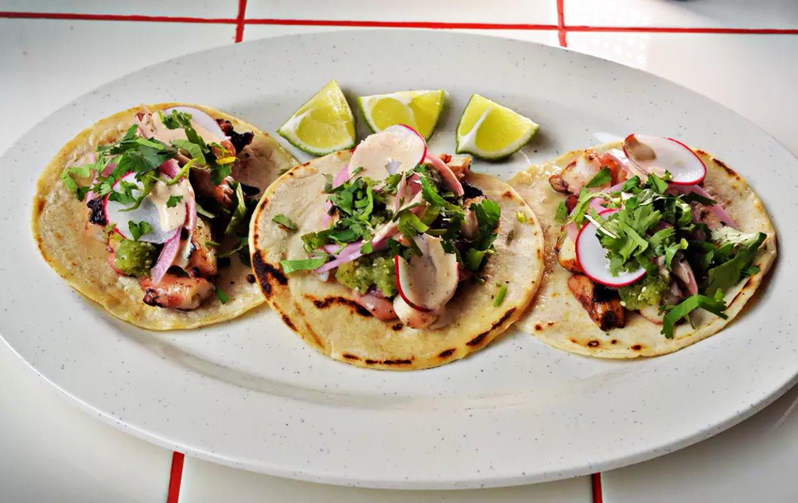

Name: 01_julio-taque_247-2022-02-14

* [DEUX22](https://deux22.com/): A Mexican-inspired resto-bar, Deux22 capitalizes on a collaborative approach that aims to pool the strengths of the team rather than the talent of a head mixologist. The liquid menu will particularly delight fans of tequila, mezcal and rum, and acidulous fruits… All good companions for quesadillas, tacos and burritos, or for the brunch menu served from 11 a.m. to 4 p.m. on weekends! $$
* [Julio Taqueria](https://juliotaqueria.ca/): Tacos are an iconic staple of Mexican street food. They’re also the signature dish at Julio Taqueria on Rue Saint-Vallier Ouest, in Saint-Sauveur. The restaurant’s kitchen team takes tacos to new heights thanks to housemade tortillas and bold, accessible flavours that hit all the right notes. The churros and sublime dulce de leche are a must for anyone with a sweet tooth.

1. Sea Food

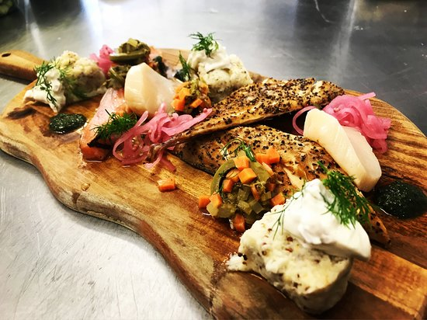

Name: assiette-du-fumoir

* [Kraken Cru](https://www.facebook.com/Kraken-Cru-841559542595409/): A glorious, but tiny seafood-driven menu which rotates weekly. Minimalist plates in a kitschy decor where the pristine flavours of Mother Nature catch all of the attention. That is until Napoleon figurines, theatrical hats and shots are passed along the to the patrons. $$$
* [Ophélia](https://restaurantophelia.com/): Chic and modern restaurant serving steaks and fine fish/seafood, with an extensive wine list and tree-lined terrace. $$$
* [Sardines](https://www.spoursardines.ca/): This deceptively modest offshoot of Buvette Scott has mastered the art of the apéro: that fabulous tradition of ending the day with a drink and a bite. Stop in for a Belgian beer with a side of Portuguese sardines, Montréal charcuterie, Québec cheese, and freshly baked crusty bread, and stay for awhile to sample chef Étienne McKinnon’s simple, delicious mains. Sardines is awash in Portugese easy living, with elegant, art-deco‑style wood furniture made by restaurant‑owner and woodworker Michel Rousseau. $$-$$$
* [Les Mordus](https://brasserielesmordus.com/?utm_source=quebec-cite.com&utm_medium=affiliate&utm_campaign=OTQ&utm_content=web): Located in Brasserie du coin, this restaurant serves up delicious food for breakfast, lunch and dinner. Les Mordus is an Old Québec eatery with a varied menu (though it specializes in fish and seafood) that will please both gourmets and those with a hearty appetite. So come in, shut off your phone and have a drink at the bar with the gang after work. On the weekends, you can enjoy a romantic dinner with your significant other or have brunch with your friends. We can provide accelerated service if you are on a tight timetable. Everyone welcome!
* [La Gaspésienne 51](http://lagaspesienne51.ca/): La Gaspésienne 51 is a 100% Gaspé restaurant prioritizing local products and fresh products; microbrewery beers, original cocktails, warm and festive atmosphere as well as an exceptional decor reminiscent of the sea, Gaspésie and fishing boats. In addition, the owner Bertrand Desbois catches the fish and seafood that we cook himself. $$$
* [Les Salles Gosses](https://www.lessalesgosses.ca/): Offering a rich and tasty cuisine, influenced by France and Italy, Les Sales Gosses, is a place where black and white are genuine accessories that contribute to enhancing the various dishes on the menu. Simplicity and comfort are the norm, both in the choice of furniture and materials used. Guests will appreciate the sleek look of the restaurant, not to mention the immense bench in the dining room, as well as the large bar that allows customers to eat on the go or enjoy an evening with friends. $$$
* [JJacques](https://jjacques.ca/#le-jjacques) : At JJacques, reflection is common between liquids and cooking. The cocktails, with or without alcohol, as well as the beers and the wines exist in complementarity with the plates and not only in parallel, which is why pairings are always offered to the guests. Moreover, the cohesion between the two makes it possible to exploit all the products to their maximum.

1. For Breakfast

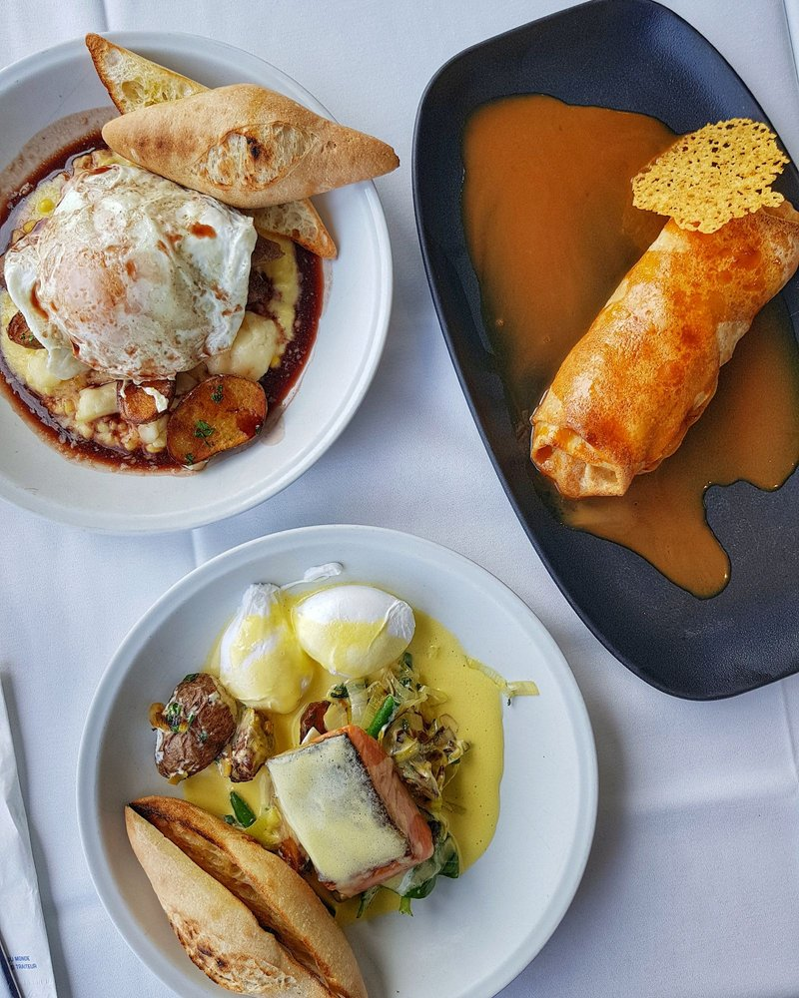

Name: ciel

* [Le Pied Bleu](https://piedbleu.com/?utm_source=quebec-cite.com&utm_medium=affiliate&utm_campaign=OTQ&utm_content=web): This Saint-Sauveur bouchon lyonnais will charm you with its genuine, generous and humble cuisine. The Pied Bleu’s food is a modest, fresh Quebecois rendition of a nose-to-tail cuisine featuring offal and giblets. It’s a hearty and festive breakfast that is best enjoyed with a group thanks to its menu served for the whole table. If you’re in for tasting something new, try the pig ear cake. It’s salty and crunchy and makes a great conversation starter. Finger licking good!
* [Clocher Penché Bistro](https://www.facebook.com/ClocherPenche/?utm_source=quebec-cite.com&utm_medium=affiliate&utm_campaign=OTQ&utm_content=web): Located in Saint-Roch, across from the church with a crooked tower, the Clocher Penché Bistrot is my favourite place to enjoy breakfast of brunch in Québec. Le Clocher’s cuisine is grounded in a locavore philosophy, yet audacious. For brunch, enjoy the finesse of the bostock with crème fraîche or a delicate grapefruit emulsion salmon tartar. If decadent food is your desire -as it is usually the case for me- indulge in l’abbé Chamel’s buckwheat waffle with Turlo's farm ham, brie, mushrooms, an unctuous béchamel sauce topped with a poached egg. $$$
* [CIEL! Bistro-bar Tournant](https://www.cielbistrobar.com/#/english): The CIEL! bistro offers the most remarkable view of Québec City. It is a rotating restaurant where in 90 minutes, 563 feet above sea level, you’ll experience a plunging 360-degree view of Québec City’s unique landscape. The CIEL!’s weekend brunch is a play on Québec’s traditions. CIEL! knows how to wow palates, one local ingredient at a time. A tasteful cuisine that I enjoyed with my Croque déjeuner, served with a generous portion of in-house smoked meat. $$$
* [Chez Boulay – Bistro Boréal:](https://chezboulay.com/?utm_source=quebec-cite.com&utm_medium=affiliate&utm_campaign=OTQ&utm_content=web) Located in Old Québec, one of the most tourist-friendly neighborhood in town, Chez Boulay stands out among tourist shops and souvenir stores. For brunch, Chef Arnaud Marchand portrays rich aromatic flavors of the boreal forest; a direct contrast with its lively location inside the city walls. On the menu: fish, meat and rich flavourful dishes served in savory sauces. Le Pêcheur is my favorite dish featuring duck fat seared potatoes and delicately smoked halibut. $$$
* [Cochon Dingue](https://www.cochondingue.com/#/english?utm_source=quebec-cite.com&utm_medium=affiliate&utm_campaign=OTQ&utm_content=web): Located near the St. Lawrence River, this restaurant has been a true local institution for more than 35 years. Stone wall decor. House specialities include the restaurant's famous breakfasts, steak and fries, ribs, seafood pot pie from Magdalen Islands and delicious desserts. Parisian terrace during the summer. Kids' menu for children under ten. $$
* [Buffet de l’Antiquaire](https://lebuffetdelantiquaire.com/?utm_source=quebec-cite.com&utm_medium=affiliate&utm_campaign=OTQ&utm_content=web): Tiny neighbourhood restaurant with a friendly family-type atmosphere. Authentic, traditional Québec cuisine found nowhere else. Fresh produce from the market. "Québécois" breakfasts with baked beans and homemade jams are one of our specialties. Served at all hours of the day. Shady terrace to relax as you eat. The Buffet de l'Antiquaire offers fine food at popular prices and is highly recommended. $

Where to sleep:

4-5 Stars Hotels

* [Fairmont Le Château Frontenac](https://www.fairmont.com/frontenac-quebec/?utm_source=quebec-cite.com&utm_medium=affiliate&utm_campaign=OTQ&utm_content=web): The iconic Château Frontenac opened its doors in 1893. This five‑star hotel defines the Upper Town skyline and offers a magnificent view of Dufferin Terrace and the St. Lawrence River below. It also boasts a premium health club and spa and 3 restaurants, including the famous Le Champlain, which has a CAA/AAA four‑diamond rating. With its gorgeous seasonal decorations, Château Frontenac is especially magical in December.



Name: Légendes-d-octobre---Fairmont-Le-Château-Frontenac_6BAD4520-58A9-4CE2-A3C7FC64163446ED_cbe2f8c3-4515-45b3-bbc5172914bf1a4f

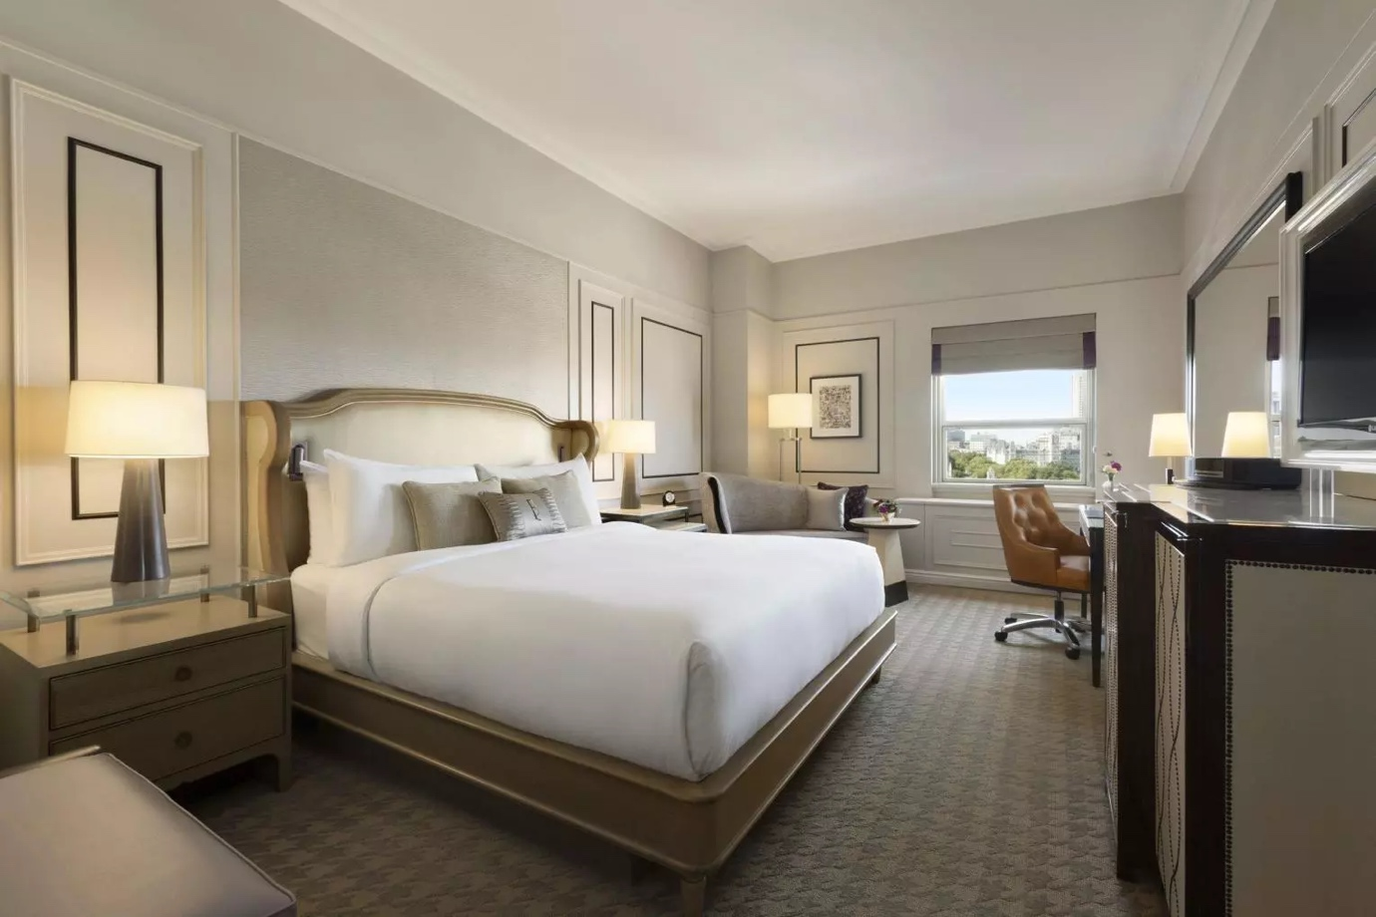

Nom : Gold-City_928B2EBE-82BD-45F8-864B072DF3666B4C_443229ea-363d-49a6-a4947271f8809a65

* [Auberge Place d’Armes](https://aubergeplacedarmes.hotelsduvieuxquebec.com/en?utm_source=quebec-cite.com&utm_medium=affiliate&utm_campaign=OTQ&utm_content=web): Located in a pair of luxurious ancestral homes at the corner of two pedestrian streets in Québec City. View of the Château Frontenac. Close to several museums, shops, restaurants, Grande Allée, the Old Port and the Convention Centre. In 2011, Auberge Place d'Armes appeared in the top 20 Canadian list compiled by Expedia Insider's Select and winner of the tripAdvisor Traveller's Choice 2014 for small hotels.

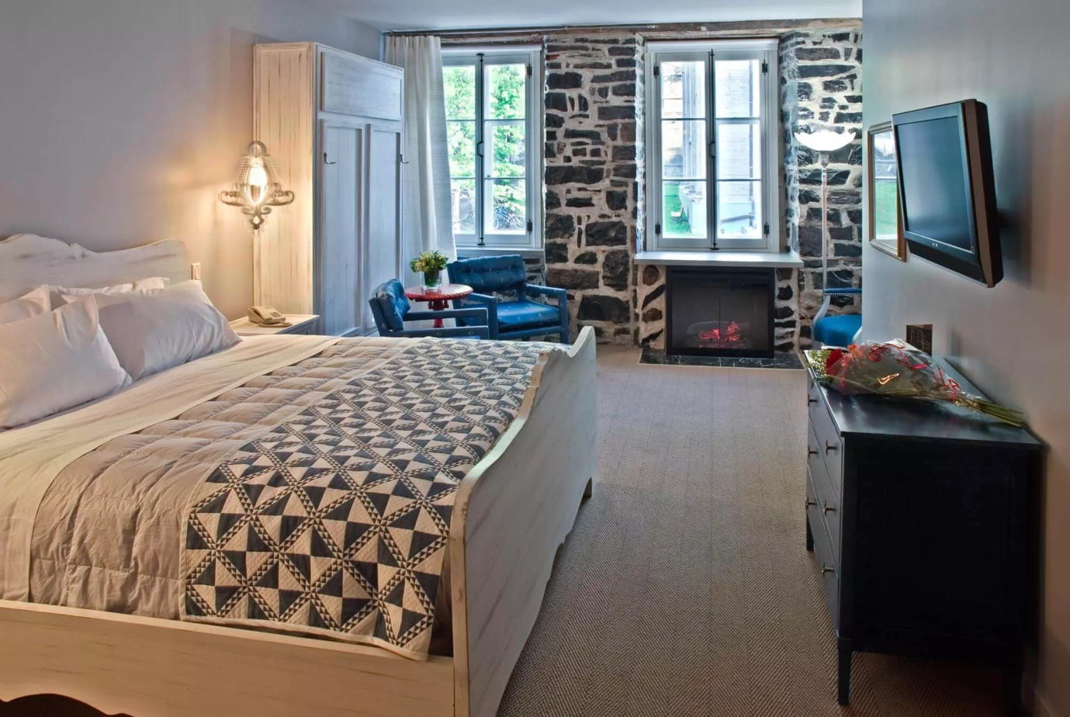

Name: Chambre-1_F1174037-D903-48DE-B55644BC7FD969E2_39dd113e-d6e9-4985-abb41c9046fc9a97

* [Hôtel Clarendon](https://hotelclarendon.com/en/home?utm_source=quebec-cite.com&utm_medium=affiliate&utm_campaign=OTQ&utm_content=web): Since 1870, the Hôtel Clarendon has been a mainstay in the Old City. Experience all the charm of this historic part of town while staying at an elegant heritage hotel with numerous modern amenities.

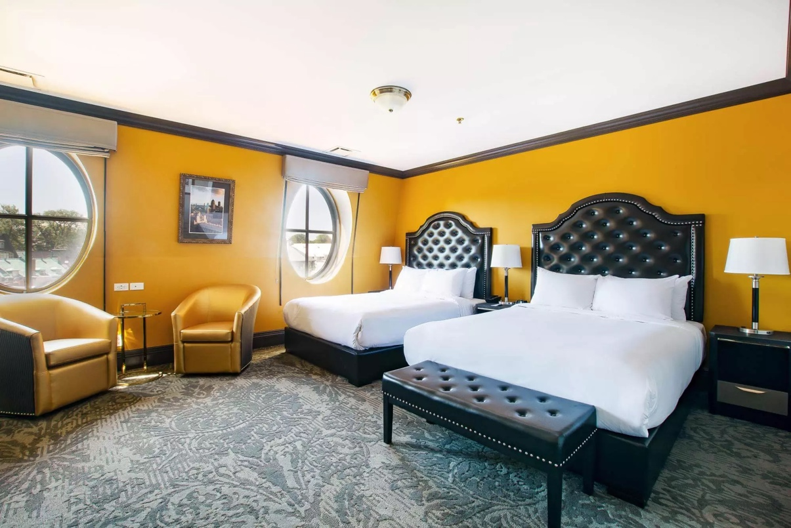

Name: _DSC0688_BA66BCC4-4DF7-49E1-8187805E17992DF0_5e95f2c9-c054-466e-b47dd5473c10408b

* [Hôtel Manoir Victoria](https://www.manoir-victoria.com/index.php/en/?utm_source=quebec-cite.com&utm_medium=affiliate&utm_campaign=OTQ&utm_content=web): In the heart of Old Québec stands the entirely renovated Hôtel Manoir Victoria which features 156 rooms of contemporary yet classical decor, designer suites and 8 multipurpose rooms for meetings, conventions and banquets (capacity of up to 175 people). The popular restaurant of the hotel: Chez Boulay-Bistro boréal, serves inventive Nordic inspired cuisine. Indoor swimming pool, indoor parking with valet service, free Wi-Fi and a team totally dedicate to your wellness!
* [Monsieur Jean – L’Hôte Particulier](https://monsieurjean.ca/en/?utm_source=quebec-cite.com&utm_medium=affiliate&utm_campaign=OTQ&utm_content=web): Your experience will be unique at every visit in our superior suites. All suites have a kitchenette, king size bed and heated bathroom ceramic floor! You will feel the comfort of home with the conveniences of a hotel. The establishment's universe is inspired by its charming, intriguing and elegant founder. The personality of the decor and employees are flamboyant. The large windows of the establishment allow you to enjoy incredible brightness and panoramic views of the St. Lawrence River, St-Jean Street and other attractions of our heritage.

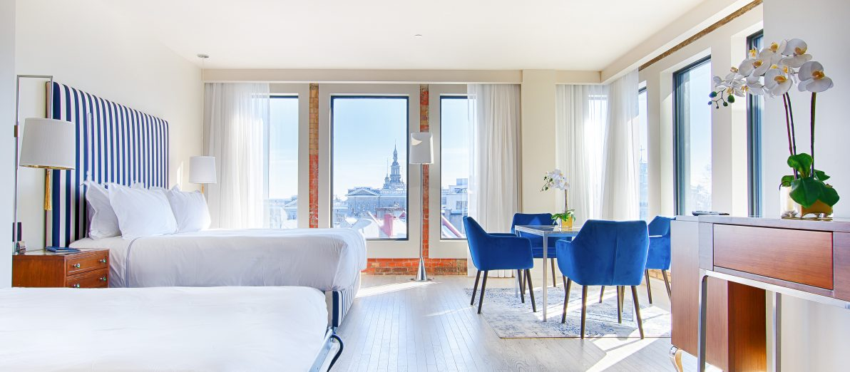

Name: DSC5501_HDR_Bok_ret-1192x522

* [L’Hôtel du Capitole](https://lecapitole.com/en/): The new, prestigious Hôtel du Capitole opened its doors in September 2019. Located in the northern wing of the building complex, this 5-star hotel has 108 rooms, suites and penthouses. The reception hall on the 7th floor, which opens onto the Clubby-Bar with its special cachet, affords a panoramic view of Old Québec. Luxurious and inviting rooms for business meetings available.

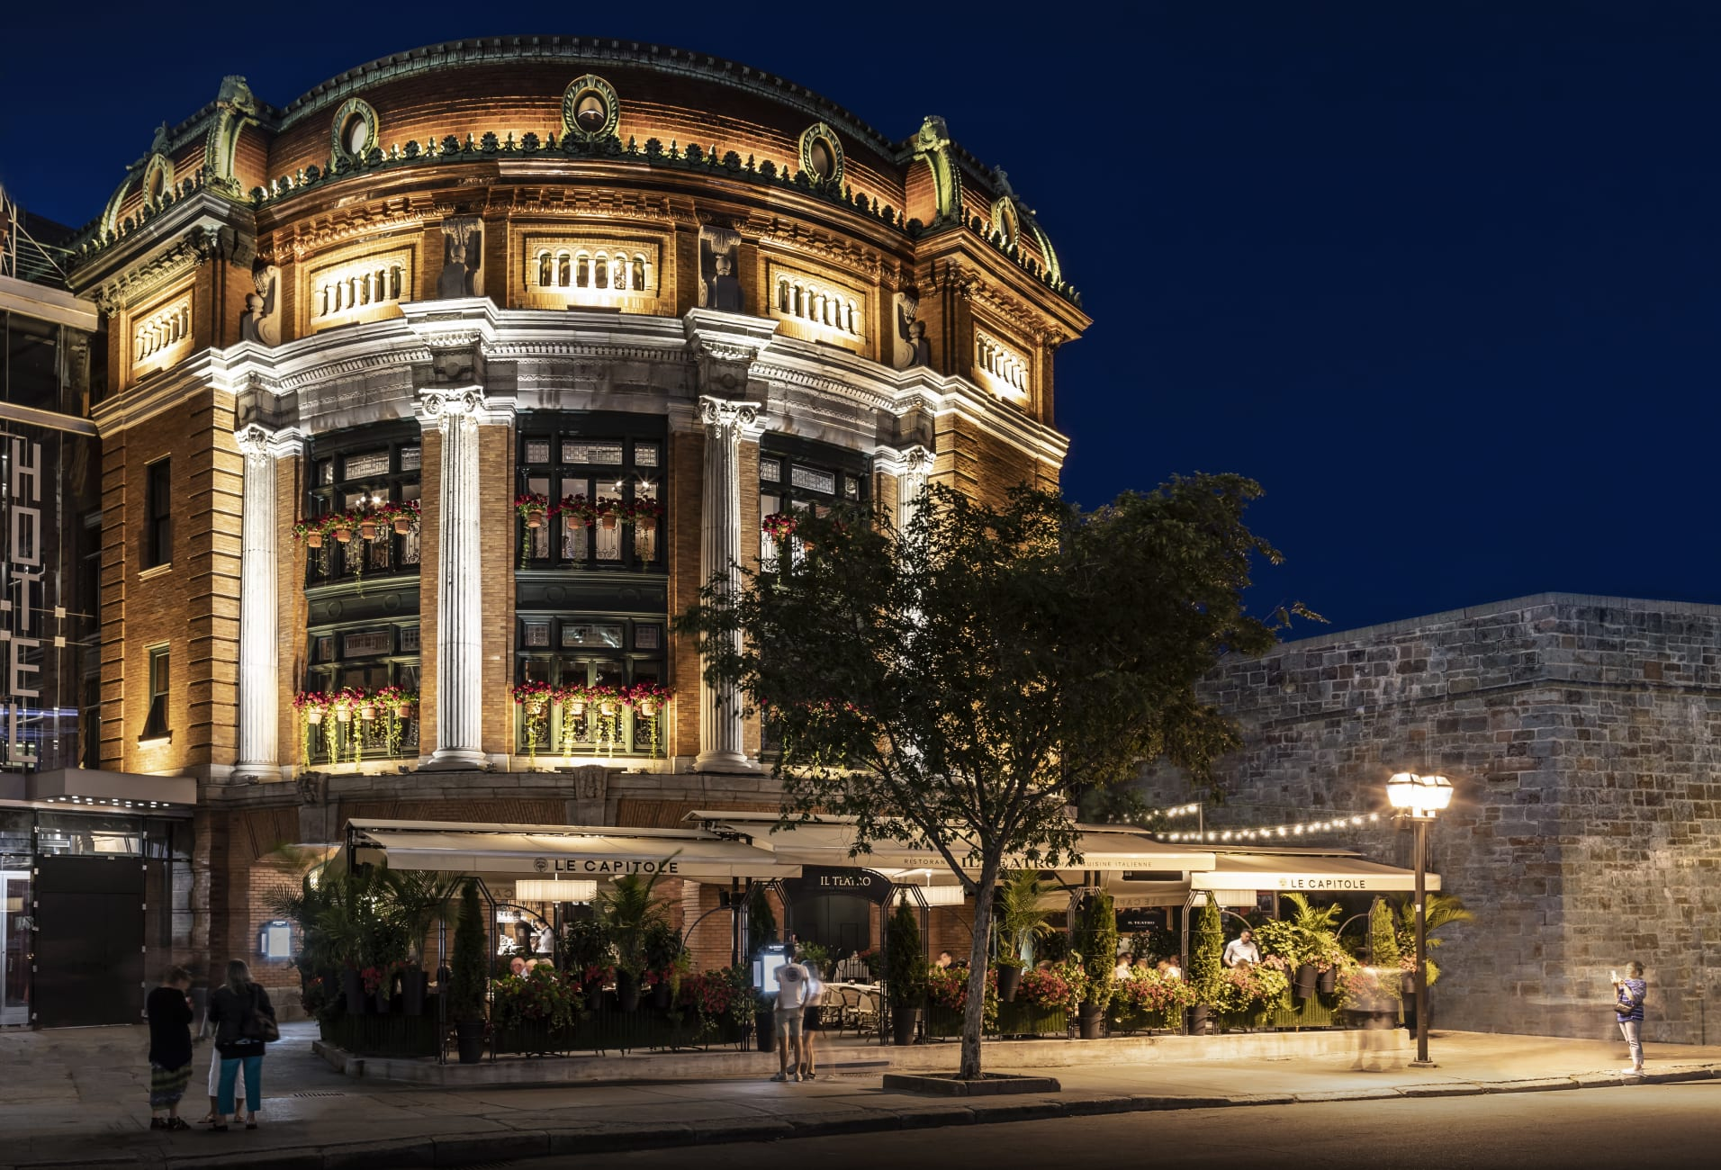

Name: 44358_v5

* [Québec City Marriott Downtown](https://www.marriott.com/offers.mi?invalidDealMsg=true): Québec City Marriott Downtown offers business travellers and vacationers an elegant, sophisticated spot from which to explore the Old Québec. Conveniently located near the City Convention Centre, our upscale hotel offers spacious rooms and thoughtful amenities. Get a good night's sleep inspired by our luxury bedding, then have breakfast in our on-site restaurant, Que Sera Sera. If you're hosting a meeting, reserve one of our five event spaces. Begin making marvellous memories when you book your stay at Québec City Marriott Downtown.
* [Hôtel Château Laurier](https://www.hotelchateaulaurier.com/en/) : Nestled between the green spaces of the Plains of Abraham and the bustling thoroughfare Grande Allée, Hôtel Château Laurier Québec combines authentic Francophone heritage and four-star comfort. In addition to our 271 rooms and suites, we offer a number of services to make your vacation, major event or business meeting more enjoyable: reputable caterer, ballroom, fitness centre, swimming pool, outdoor spa and more! We are Québec City's premier event and catering hotel!
* [Hilton Québec](https://www.hilton.com/en/hotels/yqbhihh-hilton-quebec/?utm_source=quebec-cite.com&utm_medium=affiliate&utm_campaign=OTQ&utm_content=web): Located just steps from Old Québec, the new Hilton Québec transforms your stay into a truly authentic experience. Modern and warm, each of the guestrooms offer spectacular views of the city. Upgrade to our Panoramic executive lounge located on the 23rd floor including breakfast, light snacks and more. Make the most of your stay with a swim in heated outdoor rooftop pool open year-round, even in winter! A unique experience. Finally, come and discover the richness of the local terroir at our restaurant.

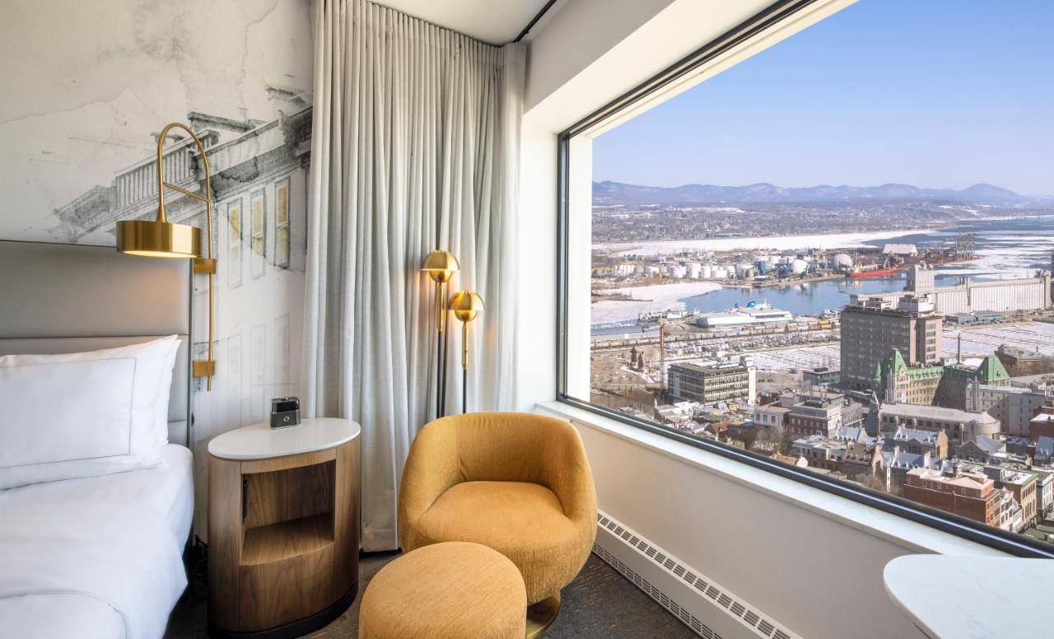

Name: 302370057

* [Hôtel Delta par Mariott Québec](http://www.marriott.com/hotels/travel/yqbdr-delta-hotels-quebec) : Located a five-minute walk from Old Québec and linked to the Convention Centre, this hotel has 14 meetings rooms with a total of 12,000 sq. ft. of meeting space. The renovated ballroom can accommodate groups of up to 500. Our rooms boast contemporary decor and cutting-edge technology, including free high-speed Internet access. Restaurant and Bar Le Bistro, fitness centre and heated outdoor pool open year-round.

Hostels

* [QBEDS Hostel](https://qbeds.ca/en/): Ideally located in the center of Quebec City, QBEDS hostel offers comfortable and intimate rooms and dorms, with a funky retro vibe and affordable prices! We are located on Grande Allee street, which is one of the most popular streets in town, with many bars and restaurants around to choose from! We are at a walking distance to most popular attractions and festivals!

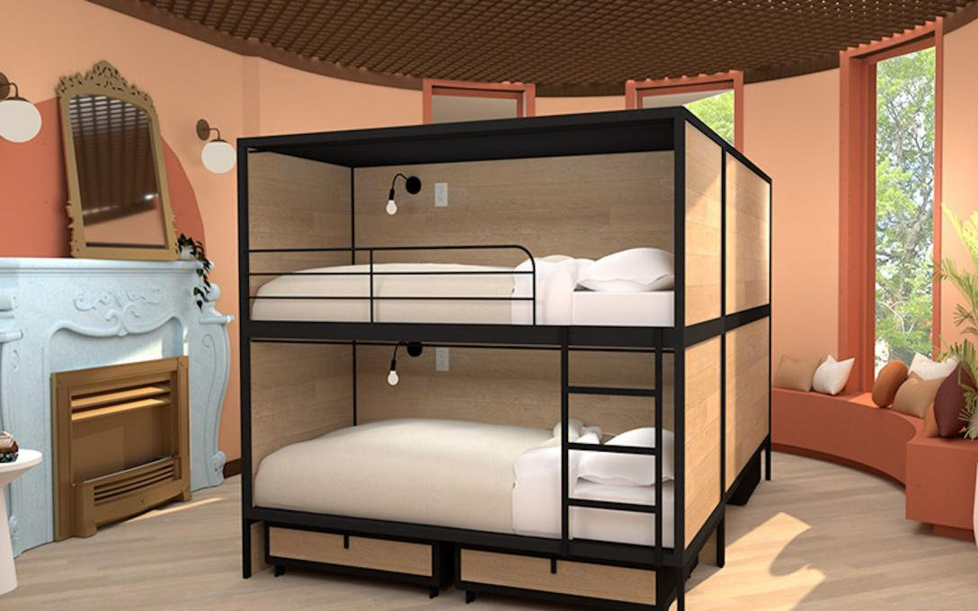

Name:QBEDS-800x500-Dortoir-2_67C67CDB-FF97-409C9D428DFF581162C7_814d382a-6c25-4872-afa20cce43a1043a

* [HI – Auberge Internationale de Québec](https://en.hiquebec.ca/): HI Québec-Auberge Internationale de Québec is located at the heart of Old Quebec City, inside the walls and fortifications of this UNESCO World Heritage Site. This characterful hostel is made up of four connected buildings dating back to the 1790’s including a former convent! It is within walking distance from the Château Frontenac and the main attractions of the city.

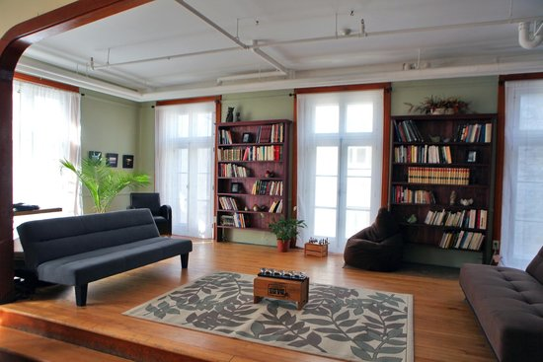

Name: hi-quebec-auberge-internationa

* [Meva Hostel](http://aubergemaeva.ca/): Located in the heart of saint Roch district, close to historic and touristic places, the hostel Maeva provides to small budget clients, a very friendly, and welcoming place where everyone will feel at home, far away from home.
* [Le Bloc Hotel](https://en.hotellebloc.com/votre-s%C3%A9jour): Former monastery renovated and converted into 33 modern studios furnished for your comfort. Book and then collect your key at our secure terminal in a 100% autonomous way. Kitchenette, Wifi, workspace ... you will have everything you need for a most pleasant stay.

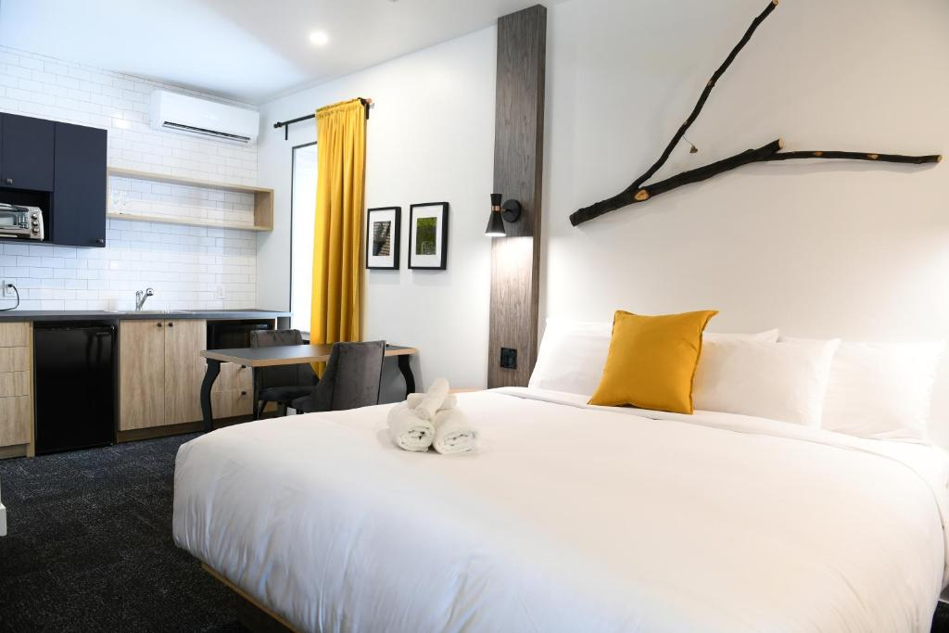

Name: 331887416

Other

Printing services

* Laval University Printing Service: <https://www.srep.ulaval.ca/impression-et-photocopie/systeme-dimpression-en-ligne/> (FRENCH ONLY)
* Centre de la Copie Élite : <https://hallessaintefoy.ca/commerce/centre-de-copie-elite/>
* Staples printing services (1400 Cyrille-Duquet, Street): <https://stores.staples.ca/qc/quebec/fournitures-de-bureau-ca-246.html>